ADF to keyvault

[terraform.tfvars - Repos](https://dev.azure.com/bupa-core/BUPA_UKIN_SCV/_git/identity-role-assignment?path=%2Fterraform%2Forg%2Fuksouth%2Fukin%2Fscv%2Fintdev%2Fterraform.tfvars&version=GBfeature%2FRupesh_Shelar_ADF_keyvault)

 ADF_to_kv = [

    {

      name               = "Key Vault Secrets User ACP-SCVDEV-ADF01"

      scope              = "/subscriptions/784be6af-1dda-43e4-b58a-a63edf1c9081/resourceGroups/rg-ukin-uks-scv-intdev-kv"

      role_definition_id = "/subscriptions/784be6af-1dda-43e4-b58a-a63edf1c9081/providers/Microsoft.Authorization/roleDefinitions/4633458b-17de-408a-b874-0445c86b69e6"

      principal_id       = "5e6961ae-d71c-49fc-84f8-cb5796937c99" # ACP-SCVDEV-ADF01

    },]

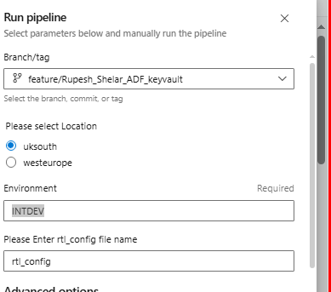

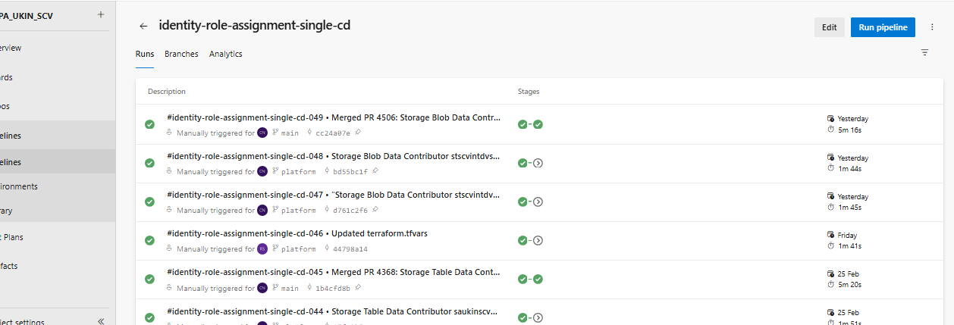

MAKE THE CHANGES IN PALFORM BRANCH AND MERGE TO THE MAIN BRANCH AFTER RUNNING

